**CASE STUDY – 6**

Observation: Enterprise Z is building a content management system that needs to manage various types of content.

Challenge 1: Designing an efficient data model.

Solution: As NoSQL DB provides schema less collections we add verity of data on fly after creating collection.

O/P:

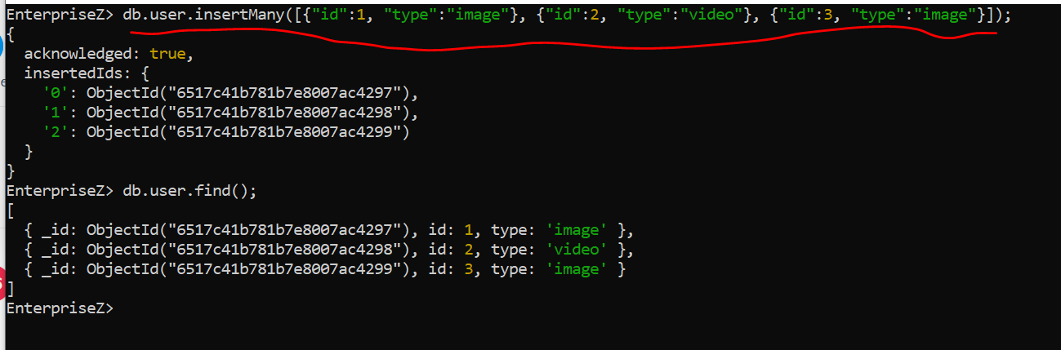

Above highlighted command is used to insert sample data into collection.

Challenge 2: Optimize Queries

Solution: We can optimize queries by adding indexes.

O/P:

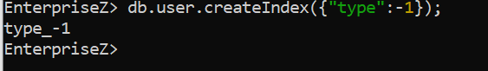

Challenge 3: Maintaining data consistency.

Solution: We can achieve data consistency using NoSQL replication feature.

Challenge 4: Adaptability

Solution: NoSQL DB are well suited for Adaptability as follow schema less data structure.

**Submitted by – Rohith Reddy**

**ID – vrddam@amazon.com**